aim games  
Sprint 1 retrospective and Sprint 2 planning

# Summons

|  |  |
| --- | --- |
| Name | Roll |
| De la Fuente Bonilla, Fco. Javier | **CEO, Project manager** |
| Molina Domínguez, Jorge Manuel | **CCO, CIO** |
| Bizcocho González, Mario | **CMO, Product Owner** |
| Arenas Arenas, Antonio  Monteseirín Puig, Alejandro  Pazo Jiménez, Pablo  Pérez Piñero, Iván  Santos Batista, Miguel | **Developers** |

# attendee

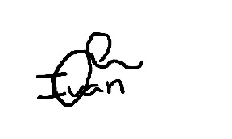**De la Fuente Bonilla, Fco. Javier Pérez Piñero, Iván**

**Arenas Arenas, Antonio Molina Domínguez, Jorge Manuel**

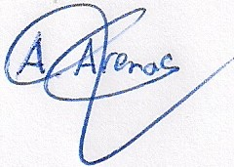

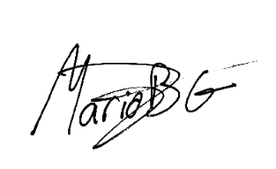**Monteseirín Puig, Alejandro Bizcocho González, Mario**

**Santos Batista, Miguel Pazo Jiménez, Pablo**

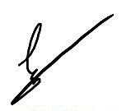

# Absent

No Proceed

# Date and place

Being on Friday March 29, 2019, and verified the attendance of all the summoned, began at 10:00 hrs. To the Sprint 1 retrospective and Sprint 2 planning for the AIM GAMES project, which ended at 13:30 hrs.

# AGENDA

1º Review of things created to date and lessons learned

2º Planning of the 2º sprint

# Development of the meeting and agreements

## Review of things created to date and discuss problems that have showed up

We have had a hard first spring because the learning and use of a new technology and some minor coordination problems, but we could give solutions to every trouble that have been showing up.

We had several problems regarding conflicts because we were not using a defined structure of branches for developing our application and our main branch (where we all committed), was the one auto deployed in Heroku, also this made the Heroku database really unstable and we had to reset it several times. In order to fix this, we created a populate file so we could easily reset and fill the database within seconds. For the second sprint we are going to put in practice Gitflow, so we can reduce the conflicts to the minimum.

We think that we are prepared to tackle the second sprint without the problems of the first spring and finish the development of the MVP and carry out the piloting plan.

## Planning of the 2º sprint

We have decided to finish the rest of cases of the MVP and focus at the security of the application, and we will start the pilot plan at the second day

# Signed in conformity

